The goal of this project is to explore data about the most urben city in u.s to icrease their profit in drug sales

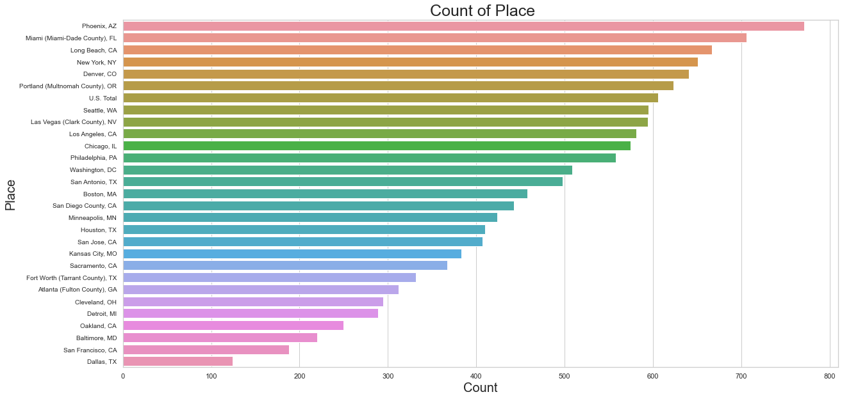

To start exploring this goal , we used a bar chart to present which city is the most count in the dataseat to choice which of them is the best to increase our sales in it.